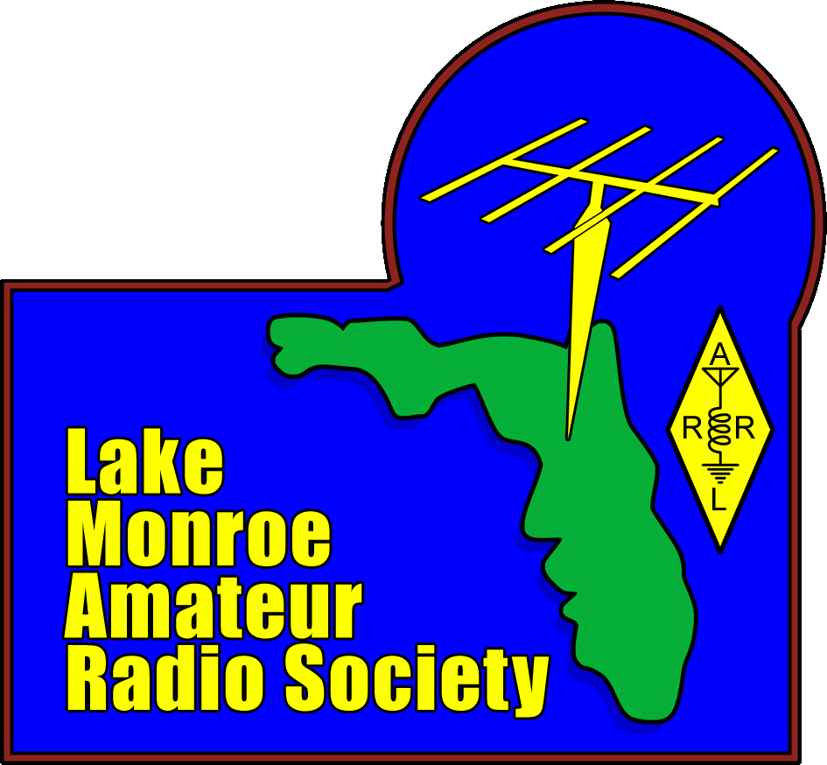 | Florida QSO Party  Operating Information  Last Updated 3/19/2024

Event Contacts
Joe Marsh (KQ4AID) 407-454-1520; Rich Fisher (W3SXX)

Come Have Fun With Us

It's that time of year again, time for the Florida QSO Party. This event is OPEN to ALL and is a great event for everyone. If you have never made a HF contact, this is for you! If you want to practice and improve your contesting skills, this is for you! If you just want to make simple contacts, this is for you!

The event will be on April 27 & 28. Stay for a little, or the whole time. There's plenty of time for everyone to get on the air, and we will be there to help if you need it. It will be a good time!

LMARS Club Operation

LMARS will set up and operate the club trailers at Central Winds Park in Winter Springs. Attendees are invited to assist with setup and teardown, this is a great learning experience. We will begin set up on Saturday at 10:00 AM teardown will starting promptly at 6:00 PM on Sunday or possibly sooner. We expect to be fully loaded out by 7:00 PM.

N4EH Contest Operation
LMARS will operate single sideband (SSB) and CW under the club’s callsign N4EH on 10, 15, 20 and 40 Meter bands. We will be using two ICOM IC-7300 radios and N3FJP logging software. It's a great contesting setup.

N4EH Example Exchange:
- <N4EH> This is N4EH, November-Four-Echo-Hotel, calling CQ FQP contest, CQ, CQ, CQ FQP contest.
- <Remote Station> [CALLSIGN]
- <N4EH> [CALLSIGN] this is N4EH, you are (59) into Seminole County Florida, that’s SEM, Sierra-Echo-Michael, how copy?
- <Remote Station> QSL, N4EH you are <Signal Report> into <Location>
- <N4EH> QSL <Remote Station Signal Report> < Remote Station Location> 73s and good luck!
- <Remote Station> 73s!
- <N4EH> QRZ?

N3FJP Contesting Screen
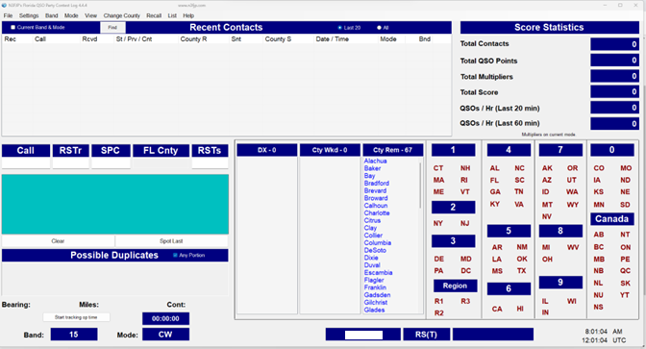

General Information (Reference https://floridaqsoparty.org/)

OBJECT: For radio amateurs outside of the state of Florida to make contact with as many Florida stations in as many of the 67 Florida counties as possible. Florida operators work anyone outside and within Florida.

CONTEST PERIOD: Starts the last Saturday of April. For 2024, the Florida QSO Party dates will be April 27th- 28th. There are two, 10-hour operating periods separated by a 10-hour break period, for a total 20 hours.
- Saturday, April 27 1600Z (**Noon EDT**) – April 28 0159Z (**9:59 PM EDT**)
- Sunday, April 28 1200Z (**8 AM EDT**) - 2159Z (**5:59 PM EDT**)
MODES: Phone, CW, Mixed (Phone and CW) No digital QSOs.
EXCHANGE: Signal report (RS or RST) and location (as specified below).
Florida operators send county. A list of abbreviations is here https://floridaqsoparty.org/counties/counties-list/
US (including KH6/KL7) operators send State. Abbreviations are here https://floridaqsoparty.org/wp-content/uploads/State-and-Province-Abbreviations.pdf
Canadian operators send province. Abbreviations are here https://floridaqsoparty.org/wpcontent/uploads/State-and-Province-Abbreviations.pdf
DX (including KP4, etc.) operators send DXCC prefix. Maritime mobile operators send ITU Region (1, 2 or 3).
RULES: Official rules can be found attached and located on the FQP website here. Please review as this also contains information on scoring and suggested operating frequencies for fixed stations to avoid providing mobile stations with better access.

